Use the strace utility to trace all system calls generated by the command cat sample.txt. Analyze the sequence of system calls and identify the kernel services involved

Output:
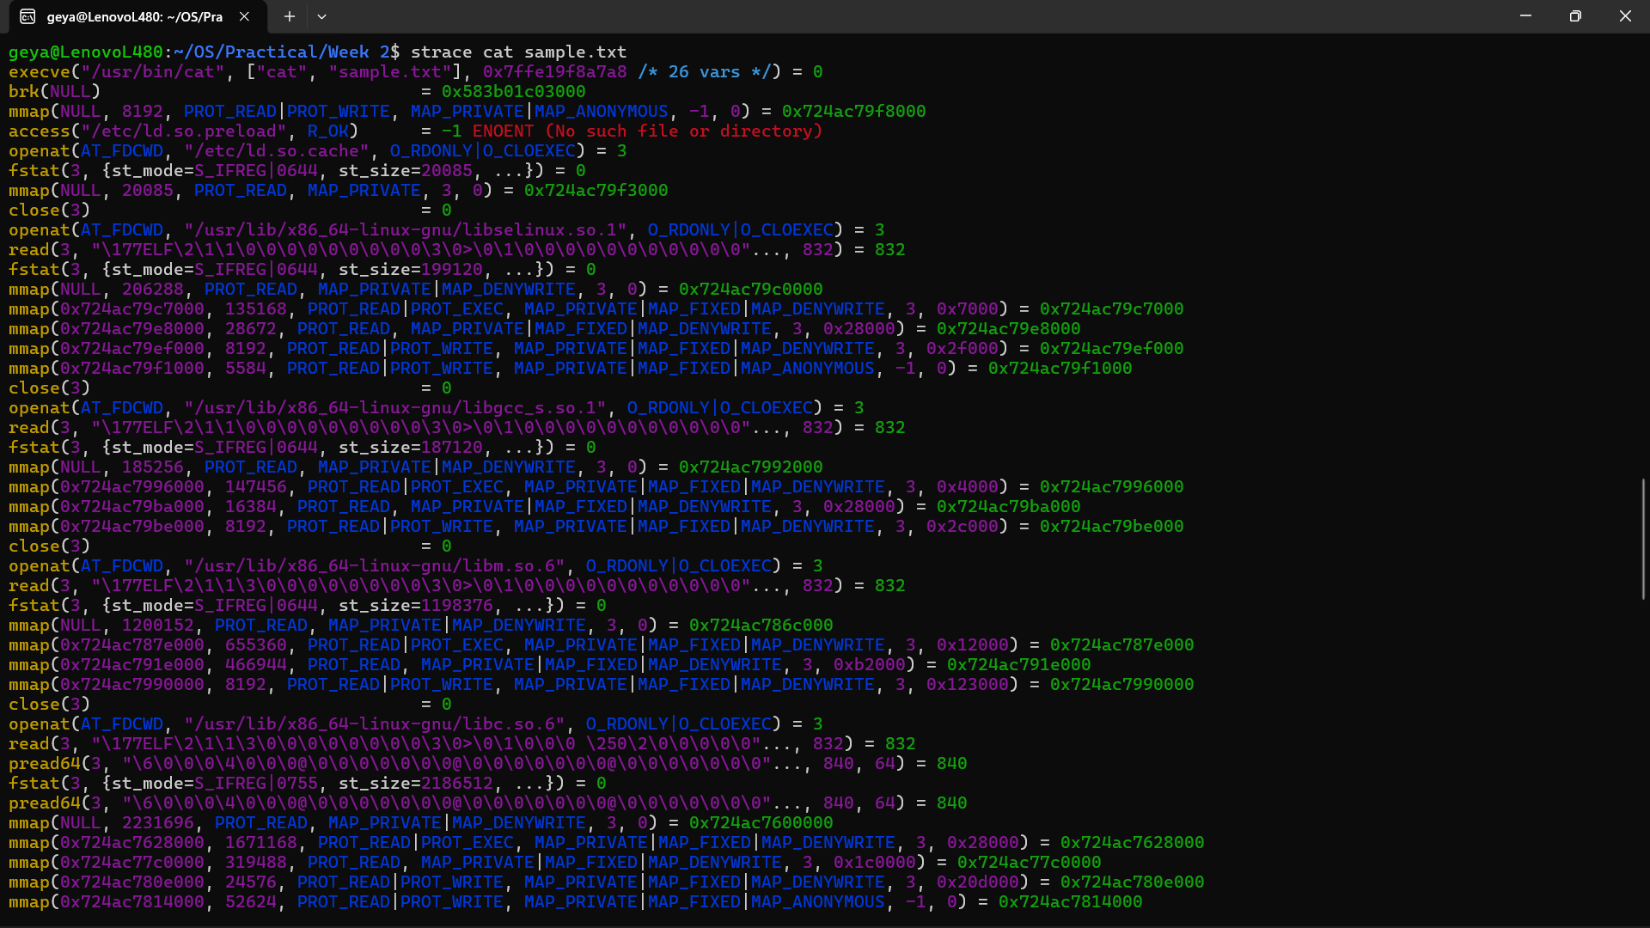

The strace command was used to trace the system calls generated by cat sample.txt. The execve() system call executes the cat program. openat() opens the file, read() reads its contents, write() displays the contents on standard output, and close() closes the file. These system calls allow the user-level cat program to request file and I/O services from the Linux kernel.

